Business Plan 2022/23

Beyond Disability Inc.

Connecting People with Technologies

Finding it difficult to keep up with technology in this fast changing world of computers, tablets and phones? Our volunteers are here to help you with all forms of technology. We help school age children, adults, carers and veterans. For a very minimal cost, our volunteers will give you all the advice you need to meet your technical problems, whether you have your own laptop, tablet or desktop computer, or would like our equipment. If you go with Beyond Disability equipment (the better option) if it needs repairing or replacing we will see to it. We offer subsidised internet access but if you are already on the NBN then we can still offer you our service and advice. If you have special needs (such as hand, eye and mobility problems), we can offer you specialised equipment to suit your requirements. Our current focus is in the south eastern suburbs, or where our volunteers are situated.
“Today technology is redefining human potential and what it means to have a disability.” Stephen Hawking

This business plan is for informational purposes to assist in determining if you wish to partner this non-profit program for Victoria’s communities helping housebound physically mobility disabled.

The financial projections that are part of this plan represent estimates based on assumptions considered reasonable, but they are, of course, not guaranteed. The contents of this plan are not to be reproduced without express written consent from the Secretary, Beyond Disability Inc.

August 2021

Executive Summary

Beyond Disability brings the world into the homes of the housebound and mobility disabled on their own terms, when they want, whilst maintaining their dignity. We now also help the technology challenged.

We are local volunteers who may be able to help in your home with your tablet, mobile or laptop to connect to broadband/NBN.
One of our major strengths is to help at home on a regular basis. We are there for those who cannot afford a laptop or broadband. Can’t afford to fix your child’s school laptop, we will help.

Beyond Disability has been active on the Peninsula for 25 years with many awards. Our volunteers hold working with children cards.

BDI supplies and maintains its equipment to save the costs of purchase, repair and software.
Where we can, BDI helps disabled of all ages, technology for disadvantaged, schoolchildren, adults on low incomes, veterans and carers.
Technology means computers, tablets, mobiles etc. capable of connecting you with family, friends and services online.

Beyond Disability has developed a cohesive community based network for the benefit of low income, housebound physically mobility disabled, through the provision of a low cost sustainable in-home communication and information network.

Beyond Disability provides computer equipment, software, and Internet access to the housebound and mobility disabled to allow communication with family and friends by e-mail, chat functions, and writing, using computer assistance. It provides access to the vast information available from the global Internet, enabling a better understanding about how other disabled people (worldwide) cope, with information on up-to-date treatments, appliances and rehabilitation aids, social skilling and just having fun. Importantly, it also provides individual training and support.

Since other means of access to the Internet, through such sources as the local library, is not feasible because of their mobility disability, these adults and children are therefore disadvantaged in their access to information and modern communication channels.

People in the program are of all ages and have paraplegia, stroke, muscular dystrophy, multiple sclerosis (from controlled to very advanced); spinal muscular atrophy; emphysema; osteo-arthritis, motor neurone disease, polio and other less well known illnesses like Erler’s Danlos syndrome are able to be assisted. Beyond Disability also has people from non-English-speaking backgrounds and single disabled mothers. Veterans with PTSD and school children from low-income families

Beyond Disability is a volunteer community program originally serving the Mornington Peninsula and now with mobile broadband we can assist people where we have a volunteer.

This program is believed to be the first in Australia to provide an online computer and Internet access plus training and support in the individual home of the housebound and elderly disabled member/family group. After over twenty years’ hard work, the Beyond Disability program is now well established and a proven success. Feedback from our community partners and participants confirm that this is a ground-breaking project which will provide a model for other projects for community based services in Victoria and beyond.

The overall goals for 2022/23 subject to Covid restrictions are as follows:

- Provide and maintain cost effective accessible technology, including subsidised wireless broadband to the housebound and mobility disabled, together with individual on-going training and support.
- Maintain a motivated, effective network of volunteers.
- Ensure effective fundraising on a sustainable basis.
- Deliver effective, sustainable management
- An important new challenge is to where we can help disabled of all ages, technology for disadvantaged, school children, adults on low incomes, veterans and carers.

Beyond Disability – Meeting a Community Need

If nothing is done, the low income, housebound, physically less-able people and carers in our community will continue to be disadvantaged in their access to modern information and communication technologies.

Medical research shows that therapeutic and preventative health is not sufficient to cure all persistent health afflictions. The Australian Bureau of Statistics shows 18 per cent of our population have a disability, that is, 2 million people. In the Beyond Disability historical catchment area on the Mornington Peninsula and rural surrounds, there are 12,500 disabled parking permits and over 45,000 people with a disability.

The quality of life for a housebound, low income mobility disabled person can be fundamentally improved by this program –

- if they want to use the Internet
- if they have the equipment to get online.
- if they have someone to show them what to do in their own home

Everyone is an individual and will need differing levels of support, which Beyond Disability tries to provide with regular home visits and our own training manual.

Information access for people with disabilities is creating numerous opportunities and challenges. There is an increasing shift to publishing Internet based documents. We have moved from the typewritten, and edited published press is to computer-generated paperless information.

Stephen Hawking said, “Today technology is redefining human potential and what it means to have a disability.”

Screen enhancements, voice synthesisers, customised keyboards, support organisations, online resources - Technology can be a wonderful equaliser – if you have access to it.

You can use technology to help fulfil your dreams. Disabled people using online technology from home are looking at the death of the tyranny of distance. On-line communication will hold the way we do many things in the future.

“We are aware of the Christopher Reeve's and Stephen Hawking’s - but there are millions of disabled, many who cannot afford a computer”.

History of Beyond Disability

Richard Stubbs, the program founder suffered severe spinal injuries in a car accident in 1991. After many visits to hospital, his son, Jason set Richard up with a computer and Internet access. Richard found in the early hours of the morning when his pain was severest, that he could manage with the distraction of “surfing” the Internet. He wrote a 300 page book on companion planting and organic gardening with his online research. Richard then decided to dedicate his resources to helping others who were also housebound with a physical mobility disability.

The project concept was formed following numerous discussions with disabled people, rehabilitation and community centres. This was followed by a survey through local newspapers.

Eventually with the support of VICNET which donated the Internet equipment and donations of computers from various companies and equipment, a working stock was established and volunteers soon joined. Frankston City Council and Frankston Communitynet together with ParaQuad Vic were the early consulting team.

Department of Communication and Information Technology and the Arts (DoCITA) provided a once-only three-year seed grant totalling $16,000.

Skillsnet provided two grants. The latter enabling Beyond Disability to change to meet the community needs. The catchment area had been declining elderly population with some mobility who could access their local library with difficulty. With the Skillsnet grant we commenced “Elderly Disabled Online” to accommodate this group. From 2014 all programmes now come under the banner of Beyond Disability.

The Department of Planning and Community Development through the Community Support Fund has provided $150,000 which has significantly assisted the program in its development and outcome achievement. New equipment has been purchased replacing older frequently faulty and older donated items.

A much needed and welcomed donation of $300,000 from Stateless Systems has enabled BDI to transfer all its clients onto wireless broadband with new equipment, costly adaptive aids (a T-bar trackball can cost up to $1000 each), Special keyboards are over $400 each.

The Beyond Disability program has a proven track record of helping housebound mobility disabled of all ages across the catchment area. We have much feedback from participants confirming that we have enhanced the quality of life of the participant and their immediate family. We have provided a means for communication with family, support groups and many other areas.

The program is operated via volunteers with significant local community and business support. We have had to adapt technology to meet some of our participants’ needs.

The success of this program can be judged from the testimonials of participants and community group partners which are contained in Appendix 4.

The Beyond disability programme was mentioned as the first NFP at the National digital Inclusion Summit Canberra 17/08/2011 by Hon senator Stephen Conroy MP.
http://www.minister.dbcde.gov.au/media/speeches/2011_-_minister_speeches/022
Not for profits - Increasing online engagement for the not-for-profit sector through such initiatives is also critical.
I’d like to point out there are already many organisations doing inspiring work to advance digital inclusion... and let me, by way of example, mention a few.
Beyond Disability, led by OAM recipient Richard Stubbs, is a team of local volunteers who assist people who are physically disabled and housebound to connect with the world by using online technologies.
Beyond Disability has provided access to computer equipment and volunteer assistance to more than three hundred people, including to some of them for more than two decades continuously.
And by the Government of South Australia in their paper –
Strong Voices, a blue print for life 2012-2020 www.socialinclusion.sa.gov.au

Quote “The Social Inclusion Board acknowledges the work of Beyond Disability Inc. led by Mr Richard Stubbs OAM, a not-for-profit organisation where a team of local volunteers in Mornington Peninsula, Victoria assist housebound people with a physical disability to connect to the world by using online technologies. Digital technology presents exciting opportunities for generating inclusion, connection and access. This is the kind of initiative that would be well supported by the proposed Local Disability Innovation Fund” End Quote.

Published by Government of South Australia Oct 2011.

Details of Beyond Disability Program

Beyond Disability Deliverables–

- Beyond Disability provides wireless broadband using commercial services to individual clients (disabled and carers) for $23 per month (inc. GST) together with a fully maintained computer, laptop or tablet, Microsoft operating systems and office software from Connecting-Up, and in-home personalised training and specialised online training and manuals.
- Beyond Disability allows disabled people who would otherwise be disadvantaged, to develop communication skills from within their own home, in their own time and with dignity, supported by caring volunteers who understand that the clients need a lot of patience and repetitive training to be able to make good use of this online technology.
- Beyond Disability has twenty-three years’ experience and has developed unique training methods customised to individual needs whether it be advanced MS, paraplegia, Parkinson’s etc. We also use voice-activated computers where needed and with adequate funds will be able to purchase required adaptive aids and software for IntelliKeys, special keyboards, touch screens, magnifiers and special trackballs.

Beyond Disability Timelines–

- Beyond Disability has been operating for twenty-three years. With a sustainable funding base the project has consolidated and will grow for the foreseeable future.

Beyond Disability Activities–

- Shut down its specific purpose dial-in server to offer broadband thereby providing affordable Internet access,
- Charges $23(inc GST) per month programme fee to clients (about 30% of real costs),
- Provides high capability equipment replaced and updated at no charge to clients,
- Obtains applicable software at low, or no, cost from Connecting-Up to meet client needs,
- Trains and supports clients with individual personalised training and specialist manuals through our volunteer’s network,
- Works in partnership with government, community groups and individuals to deliver above.

Beyond Disability Achievement Awards–

Beyond Disability has been awarded:
- One of two Australian-based not-for-profits nominated to the inaugural FACSIA 2007 inclusion award;
- City of Casey most innovative program and also best family and community programme;
- Beyond Disability volunteers have also received best Volunteer – City of Casey 2002 and 2008;
- CEO was awarded an Order of Australia in the Queen's honours list 2008
- CEO has also received the Rotary International Paul Harris Fellow which is the highest award globally Rotary can issue.
- Beyond Disability volunteer received MPs Award for Community Service in 2013.

Goals and Objectives – 2022/23

Beyond Disability will continue to help housebound physically mobility disabled of all ages and seek help from the philanthropic groups to ensure the program continues to grow. We will develop partnerships with our support groups - Anglicare, Brotherhood St Laurence, Catholic Education Board / Church, Rotary and others. We will maintain our program strength, being, local volunteers with local enterprise, helping local less abled.

The detailed overall goals for 2022/23 are:

- Provide and maintain cost effective accessible technology with broadband to the housebound and mobility disabled, together with individual on-going training and support
- Maintain a motivated, effective network of volunteers.
- Ensure effective fundraising on a sustainable basis.
- Deliver effective, sustainable management

Objective 1: Provide and maintain cost effective accessible technology:
The specific individual goals within this area include:
- The provision of a cohesive, sustainable community based information network for the benefit of low income, housebound physically mobility disabled;
- The provision of in-home broadband Internet capable computer facilities for the housebound mobility disabled participants with respect for their privacy and dignity.
- An increase in the number of participants.
- The maintenance of specialised training programs for participants and provision of in-home training and support through the volunteer network;
- Continuing to meet the special needs of individuals with paraplegia, multiple sclerosis, spinal muscular atrophy, stroke, emphysema, muscular dystrophy, spinal and arthritic degeneration, polio, obesity, Parkinson’s, motor neurone disease and any other disabilities.
- Annually review of contingency plans and cost-effective long term alternative locations for program hardware and service facilities.
  - Of necessity, the initial workshop and server hardware facilities were established at the home property of the founder. While this has obvious cost advantages there are longer term risks. We need a secure venue with disabled access & facilities, monitored security and parking.
- The investigation of future Internet Service Provider facilities to reflect developing technologies
Initial hardware provided was based on a severe shortage of funds. With the growth of the program services and client base it is necessary to investigate options for appropriate future facilities. In addition, demand is growing for the adoption of new adaptive technologies to enable computer use by people with particular disabilities.

Vicnet initially provided our program with a donated community Internet Service which was extremely slow. The same access from a commercial provider would have been cost prohibitive to our users. The Community Support Funds were used to update the Internet Service equipment to state-of-the-art equipment with a 10 line ISDN and ADSL in lines. This equipment had a replacement value of $86,000.

To meet the needs of our clients we began engaging broadband services and now all clients are provided with wireless broadband or may use their own broadband service.

The benefit of the broadband is that we can now provide the program in the future to 95% of Australia.

- Maintain appropriate networking to continue access to low cost computer hardware and software, in addition to utilising funding provided for new equipment and adaptive aids

Objective 2: Maintain a motivated, effective network of volunteers:
The program cannot operate without the enthusiasm, commitment and energy of the volunteers. Maintaining their support and morale is a critical success factor for the project.
The key actions to achieve this objective are;
- The preparation of specific advanced audio-visual and other training aids to improve volunteer training;
- The development of a program of mentoring, social and other programs to build morale and support volunteers;
- The recruitment of more volunteers to support the expected increase in clients;
- Support, train and ensure expert advice is available for volunteers;
- Be a conduit for local communities, local governments and service organisations support;

Objective 3: Ensure effective fundraising on a sustainable basis:
Access to sufficient ongoing funding is the key to expanding the number of participants in the project. With tax deductibility of donations approved by the Australian Taxation Office it is now possible to pursue ongoing funding on a systematic basis.
Beyond Disability has been assisted hugely by the generous grants and donations of Government, benevolent organisations and supporters. This has included:
- Dame Elizabeth Murdoch AC, DBE (now deceased)- a most generous mentor and supporter for 14 years;
- Stateless Systems for most generous support;
- FACSIA grants for volunteer travel reimbursements;
- Mornington Council; Frankston Council; Casey Council;
- Bendigo Bank Community Fund.
- The Department of Planning and Community Development through the Community Support Fund (CSF);
- The Newman's Own Foundation;
- Baillieu & Sarah Myer and Janet Calvert-Jones family foundations;
- Connecting-Up / Donor Tec – provision of software at nominal cost.
Key actions to achieve this objective are:
- Develop Fund raising support material e.g. The Beyond Disability Story;
- Build on volunteer Fund Raising training undertaken in last business period to implement an effective fundraising;
- Develop package based upon sponsoring specific individuals.

Objective 4: Deliver effective, sustainable management:
Volunteer organizations are highly dependent upon the enthusiasm and skills of the leadership group. The program has been increasing its client list each year since inception.
To maintain this growth rate while ensuring continuing high quality service delivery it is essential to ensure the continuity of this leadership.
Key actions to achieve this objective are:
- Develop a leadership group contingency and succession plan.
- Undertake a comprehensive review of risks and implement an appropriate risk management program.
These activities are represented diagrammatically on the following page.

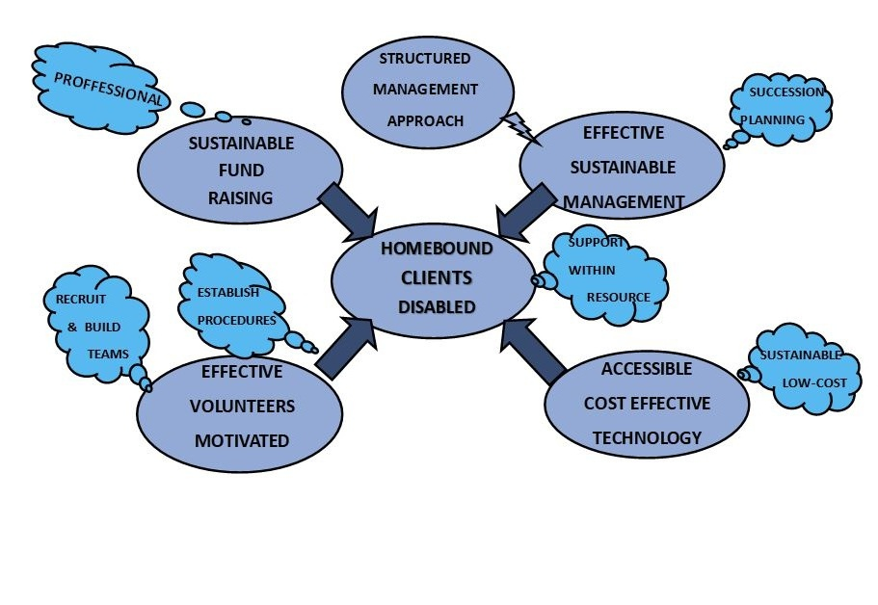

Risk Management

The key strength of Beyond Disability is that it has operated for some twenty-five years and has developed a good understanding of the challenges and risks of the program.
The key risks that have been identified are:
Maintaining network of support and training volunteers;
Maintaining pool of volunteers to build cost-effective computers;
Development of partnerships to source usable donated computers and laptops. This recycling of computer equipment is also greenhouse friendly;
Continuity of funding;
Loss of key management personnel;
Continued access to current Workshop location;
Insurance and Risk Management.

Appropriate risk mitigation strategies and plans are being developed and are included in the objectives of this plan.

The performance of the program will be determined on an ongoing basis through the active monitoring of key performance measures. These will include client numbers, volunteer numbers, client and volunteer turnover, attitude surveys and unit service costs.

Financial Information

Financial Information: Financial Years Ending 2007-2022 and Budget 2023

Beyond Disability Budget 2022/23

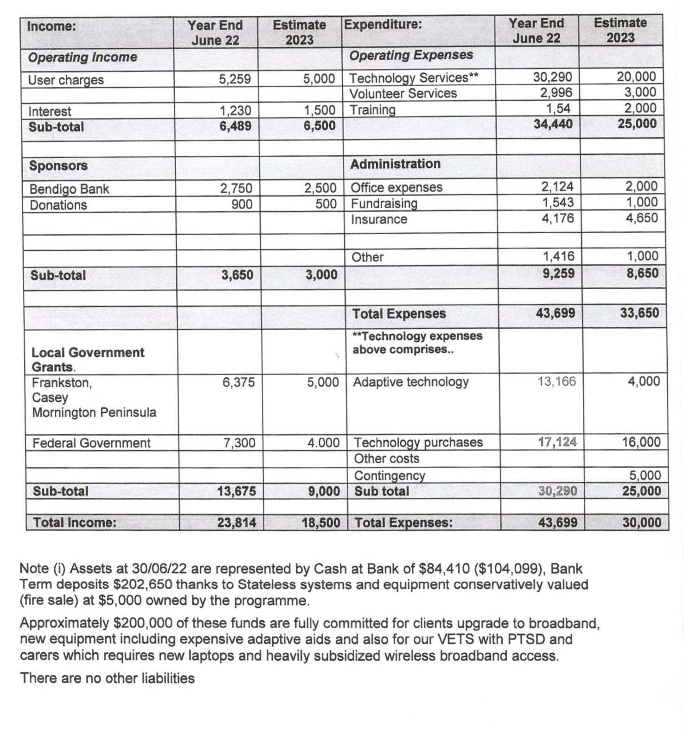

Income: | Year End  June 21 | Estimate  2022 | Expenditure: | Year End  June 21 | Estimate  2022
Operating Income |  |  | Operating Expenses
User charges | 4,596 | 4,500 | Technology Services | 26,840 | 20,000
 |  |  | Volunteer Services | 1,231 | 1,000
Interest | 2,455 | 500 | Training | 331 | 1,000
Sub-total | 7,051 | 5,000 |  | 28,402 | 22,000
Sponsors |  |  | Administration
Bendigo Bank | 5,500 | 3,000 | Office expenses | 1,709 | 1,500
Donations | 130 | 150 | Fundraising | 1,258 | 1,000
 |  |  | Insurance | 4,421 | 4,000
 |  |  | Postage(Covid) | 948 | 500
 |  |  | Other | 1,551 | 1,000
Sub-total | 5,630 | 3,150 |  | 9,887 | 8,000
 |  |  | Total Expenses | 38,289 | 30,000
Local Government Grants. |  |  | Technology expenses above comprises..
Frankston,  Casey  Mornington Peninsula | 4,800 | 4,000 | Adaptive technology  Wheelie Kids | 3,783 | 4,000
Federal Government | nil | 500 | Technology purchases | 23,057 | 16,000
 |  |  | Other costs
 |  |  | Contingency |  | 5,000
Sub-total | 4,800 | 4,500 | Sub total | 26,840 | 25,000
Total Income: | 17,481 | 12,650 | Total Expenses: | 38,289 | 30,000

Income: | Year End  June 20 | Estimate  2021 | Expenditure: | Year End  June 20 | Estimate  2021
Operating Income |  |  | Operating Expenses
User charges | 4,831 | 6,000 | Technology Services | 22,290 | 22,000
 |  |  | Volunteer Services | 2,453 | 4,000
Interest | 5,026 | 5,000 | Training |  | 3,000
Sub-total | 9,857 | 11,000 |  | 24,743 | 29,000
Sponsors |  |  | Administration
Bendigo Bank | 2,500 | 2,500 | Office expenses | 2,665 | 2,000
Donations | 100 | 1,000 | Fundraising | 966 | 1,000
 |  |  | Insurance | 4,247 | 4,400
 |  |  | Accounting/Audit | 1,045 | 1,000
Sub-total | 2,600 | 3,500 |  | 8,923 | 8,400
 |  |  | Total Expenses | 33,666 | 37,400
Local Government Grants. |  |  | Technology expenses above comprises..
Frankston,  Casey  Mornington Peninsula | 6.031 | 5,000 | Adaptive technology  Wheelie Kids | 2,200 | 5,000
Federal Government |  |  | Technology purchases | 20,090 | 22,000
 |  |  | Other costs |  | 1,000
 |  |  | Contingency
Sub-total | 6,031 | 5,000 | Sub total | 22,290 | 28,000
Total Income: | 18,488 | 19,500 | Total Expenses: | 33,666 | $37,400

Financial Year | 2018/19 | 2019/20 | 2020/21 | 2021/22
Income | Actual  Audited | Actual  Audited | Actual  Audited | Actual  Audited
Government Grants |  |  |  | 7,300
Council grants (LGA) | 4,832 | 6,031 | 4,596 | 6,375
Participants | 5,059 | 4,831 | 7,550 | 5,259
Federal Government
Philanthropy | 997 | 100 | 130 | 900
Bendigo Bank Community | 3,000 | 2,500 | 2,750 | 2,750
Interest | 5,801 | 5,026 | 2,456 | 1,230
Total Income | 19,689 | 18,488 | 17,482 | 23,814
Expenses
Program | 31,979 | 25,201 | 26,840 | 34,441
Operations | 7,846 | 8,465 | 10,174 | 7,715
Fundraising |  |  | 1,282 | 1,543
Other
Total Expenses | 39,825 | 33,666 | 38,289 | 43,699

Financial Year | 2014/15 | 2015/16 | 2016/17 | 2017/18
Income | Actual  Audited | Actual  Audited | Actual  Audited | Actual  Audited
Government Grants
Council grants (LGA) | 6,669 | 14,056 | 7,200 | 5,200
Participants | 9,306 | 8,758 | 8,848 | 11,620
Federal Government
Philanthropy
Other | 485 | 2,273 | 4,500 | 6,306
Interest | 6,828 | 10,855 | 8,993 | 6,240
Total Income | 22,472 | 35,942 | 29,541 | 29,366
Expenses
Program | 37,245 | 37,109 | 30,651 | 34,091
Operations | 6,129 | 2,049 | 4,456 | 5,608
Fundraising |  | 2,090
Other
Total Expenses | $43,374 | 41,248 | 35,107 | 39,699

Financial Information - Historical

Financial Year | 2010/11 | 2011/12 | 2012/13 | 2013/14
Income | Actual  Audited | Actual  Audited | Actual  Audited | Actual  Audited
Government Grants | nil | nil | nil | nil
Council grants (LGA) | 11,810 | 6,431 | 9,238 | 6,669
Participants | 4,370 | 9,826 | 13,846 | 10,495
Federal Government | nil | Nil | nil | 3,000
Philanthropy | 52,000 | 56,172 | 48,466 | 10,500
Other
Interest | 17,214 | 17,144 | 9,942 | 7,961
Total Income | 85,394 | 89,573 | 81,492 | 38,625
Expenses
Program | 82,791 | 59,997 | 58,853 | 50,632
Operations | 3,066 | 2,561 | 2,886 | 3,774
Fundraising | 1,671 | 485 | 1,458 | 400
Other
Total Expenses | 87,528 | 63,043 | 63,197 | 54,806

Financial Year | 2006/07 | 2007/08 | 2008/09 | 2009/10
Income | Actual  Audited | Actual  Audited | Actual  Audited | Actual  Audited
Govt Grants/CSF | 30,000 | 30,000 | 30,000 | nil
Council grants | 5,200 | 7,700 | 15,500 | 18,000
Participants | 8,355 | 8,546 | 8,018 | 7,364
Fed Government |  | 12,200
Stateless Systems |  |  |  | 300,000
Philanthropy | 35,631 | 12,495 | 66,829 | 48,700
Other |  | 7,428 | 3,195 | 12,255
Newmans Own | 31,000
Total Income | 110,186 | 78,369 | 123,542 | 386,319
Expenses
Program | 75,149 | 88,184 | 90,595 | 79,432
Operations | 2,907 | 2,660 | 3,015 | 3,588
Fundraising | 1,782 | 1,506 | 1,458 | 1,365
Other
Total Expenses | 79,838 | 92,350 | 95,068 | 84,385

Appendix 2

Legal Structure

Beyond Disability Inc (BDI) formerly Rural & Peninsula Disability Support Incorporated (RPDS) is an incorporated association in Victoria. Incorporated association number A0037035K , ABN 82 846 344 613 . The program started in 1997

BDI is a registered charity in Australia and has Gift Deductibility Status & 4.1.1Public Benevolent Institution Status from the Australian Taxation Office.

BDI Contacts;
Richard Stubbs, CEO 0417 786 087 helpful@bdi.org.au
Tricia McGill, Team Leader 0419 114 313 tmcgill@bdi.org.au
Peggy Stocks, Secretary secretary@bdi.org.au

BDI is under the control of a management committee of community representatives. Details of the management committee are as follows.

Management Committee 2022 - 2023

CEO: Richard Stubbs OAM retired disabled Bank Executive
Secretary: Margaret (Peggy) Stocks
Treasurer: Amanda Lewis
Technical: Ian George and Klaus Jungling
Team Leader/Funding Tricia McGill
Consultant Malcolm Fowler
General Committee Cindy Reed

Appendix 3

Celebrating Beyond Disability Success

Community Partner Testimonials

“Although MND sufferers are trapped in their bodies, their minds are still very sharp. This affliction is also extremely hard on their loved ones who are ever so grateful for the computer communication received. We need Beyond Disability to continue their valuable service for the disabled who get so much pleasure from something we take for granted.”
The Motor Neurone Disease Southern President

“The outstanding success and achievements of the Beyond Disability program getting disabled online has added a new dimension to their lives. Clearly, it has provided a wonderful opportunity for people to express their desire to communicate with others and their poetry and stories indicate that whilst they have physical limitations – their ability to express themselves is not limited.”

ParaQuad President
Foreword to BEYOND DISABILITY book “Thoughts and Feelings”

The Beyond Disability Program is an outstanding success and ParaQuad is proud to have been able to assist in some small way since its inception.” Peter Prendergast CEO

Participant Testimonials

Congratulations to all the volunteers at Beyond Disability, on reaching 20 years doing such fabulous work! What an amazing achievement for you all. We want you to know how much your support has meant to Jaz, and all our family, over the last ten or so years.
It has especially benefitted Jaz’s schooling. She is now in Year 11 and doing very well. We are very appreciative to all at Beyond Disability.
Many Thanks from Rod, Linda, Jasmine and Jacob Rigby-Smith (2017)
~~~~~~~~
This is a letter to explain what BDI has allowed me to do over the past years, I was lucky to be talking to one of my carers about buying a second-hand computer and she told me about BDI who she had read about in the local paper so I made some enquiries and found out more. I really do feel so lucky that I was told about them, they have supplied me with a computer that is voice activated which allows me be to be able to use the computer as my hands no longer can use the keyboard, they also send around a volunteer helper which is really helpful because I had never used a computer before and luckily she has patience of a saint. I can send e-mails to my Aunt and Uncle overseas and I receive quite a few jokes which do amuse me. It has opened a new world to me the learning has not been as easy as I thought but at least it has challenged my mind and also taught me more. I must also say that Richard Stubbs, the man in charge of BDI--I should probably say the founder, can't seem to do enough for me this is why I feel so very lucky that I was able to find them.
I'm so lucky to have Tricia McGill keeping her eyes open for anything that might help me, she found out about this company Comtec who was able to bring out a Penny and Giles joystick roller! Having this type of control makes it so much easier for me to control the mouse (less time correcting). Regards Lynn Roberts (2006)
~~~~~~~
The company BDI provides a service that is invaluable to the disabled people. It supplies a service that is unquestionable unique in helping disabled people to operate computers and systems, that would be impossible for disabled people to operate.
In many instances, many disabled people would not be able to operate such intricate equipment without the economic assistance in procuring such equipment. I appreciate the equipment and assistance the BDI supplies. Many thanks. Cheers Graeme Johnson (Deceased)
~~~~~~~~~
My name is David Cuffe and I would like to tell you about my experiences with computers before getting in touch with B.D.I. It is so easy to explain, as I have none at all. I happened to meet this lovely couple just around the corner from my home. Peg Stocks and her husband John deserve a lot of credit for getting me off my backside and having a go on the computer. I have not really been interested in electronics as I thought it would be far too hard to learn.
SURPRISE!
With Peg as my teacher and her having so much patience I am starting to have some fun, learning has been a new experience but I now find that I am enjoying my days by talking and messaging my new friends and family although I do struggle at times. B.D.I deserve a lot of credit for the message they are putting out there.
Thank you all very much. I wish you all a great time and hope we can let the people that need to fill in their time by getting in touch with BDI. A special thank you to a special couple in Peggy and John Stocks. Yours sincerely David Cuffe 2020
~~~~~~~~~~~~
Many thanks to all the BDI team for the good work that they do. Since I had to stop driving a while back, I rely on my computer for the occasional purchase, paying bills, email contact etc. Thanks again to all the team for your good work. Cheers from Martin Fisher.
~~~~~~~~~~~
We would like to thank all of you at BDI. It’s a beautiful gesture & we really appreciate it so again thanks cheers Wendy & Peter Thompson 15th June 21
~~~~~~~~~~
On John's behalf, I would like to thank BDI for helping John out with the laptop and over the years, it has made life easier for him and certainly made a difference. Thank you Ian for your technical support and making the learning curve with the laptop smoother. Also thanks for sending the parcel post bag so I can return the Telstra broadband device to you.
Kind regards and cheers for now, Claudia (and John) Watson.
~~~~~~~~~
Appreciate all the help, thanks Tricia! Stay safe BDI team! Kind regards, Lindy (Cooke).
~~~~~~~~~~
I need to thank you so much for the great effort you have made to assist with the changeover of windows 10 for me.... this has been a great deal of extra work for you just to appease me because I have difficulty with any change of any kind. I can see how much extra work you have put into this great effort. Please accept my apologies for being such a nuisance.
I appreciate your efforts so much. Thank you, Klaus, so very much. Kind regards, Leonie.

